**Functional Design**



***Names:*** *Kevin Ly, Marco Havermans and Pieter Hoek***Place:** Breda, Terheijdenseweg 350, 4802 HM**School:**  Radius College**Project group:** 6

Table of Contents

Use case diagram 3

Use Cases 4

Add Bills 4

Edit Bills 4

Archive Bills 5

View Bills 5

Add Customer 6

Edit Customer 6

Archive Customer 7

View Customer 7

Activity Diagrams 8

Add Bills 8

Archive Bills 8

Edit Bills 9

View Bills 10

Add Customer 10

Archive Customer 11

Edit Customer 11

View Customer 12

Versions 13

# Use case diagrams

## Customer Processing System

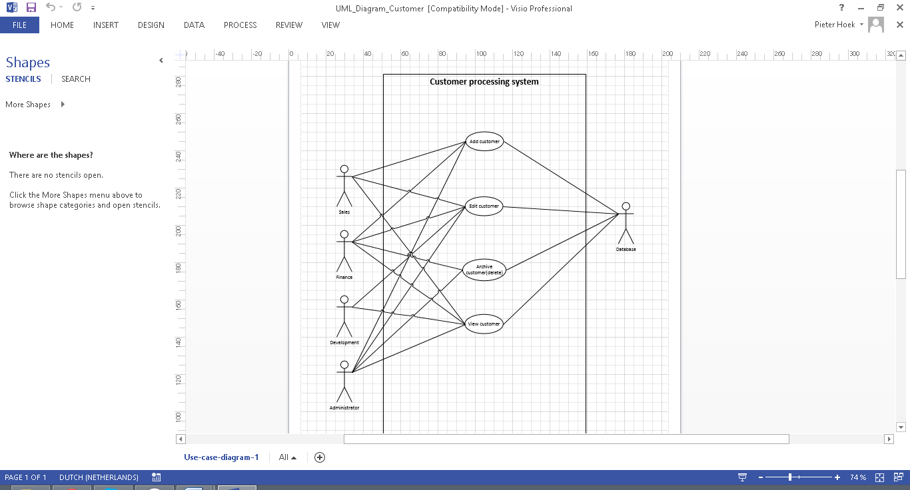

## Billing Process System

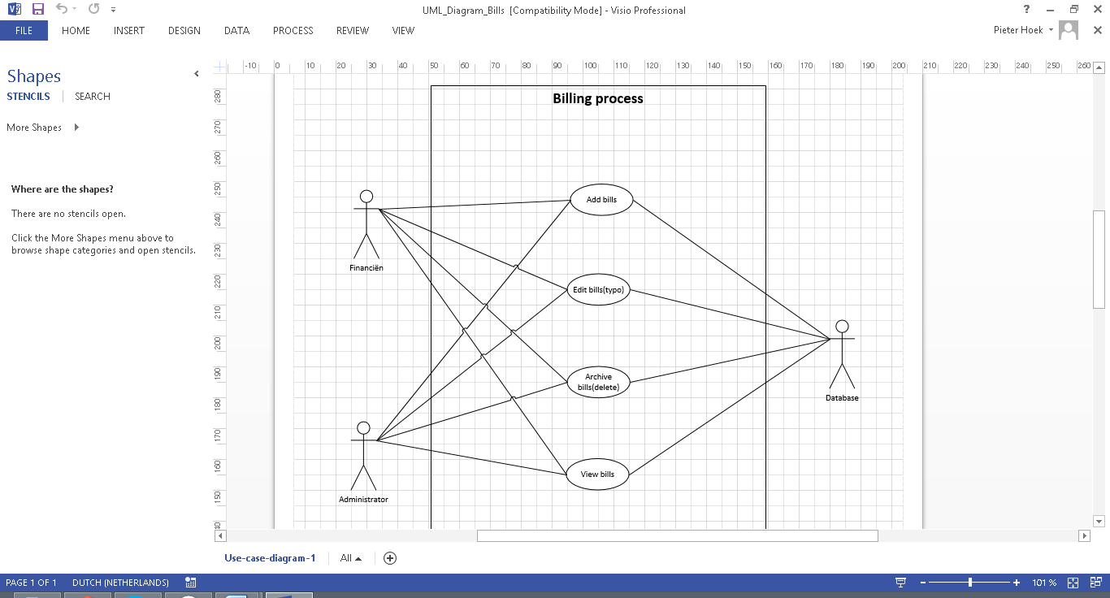

# Use Cases

## Bills

### Add Bills

|  |  |
| --- | --- |
| **Name** | Add bills |
| **Version** | 1.0 |
| **Actors** | Finance, Administrator, Database |
| **Pre-condition** | User has logged in.  User has selected the customer.  User has pressed "Add bill" |
| **Description** | User fills in the complete bill details.  User clicks "Add bill".  System displays message "Bill successfully added". |
| **Exceptions** | Bill details inserted incorrect. message: "The field (field) is incorrect". |
| **Non-functional requirements** | Bill can be added to the database in 10 minutes. |
| **Postcondition** | Bill is added to the database, system waits for action from user. |

### Edit Bills

|  |  |
| --- | --- |
| **Name** | Edit bills(typo) |
| **Version** | 1.0 |
| **Actors** | Finance, Administrator, Database |
| **Precondition** | User has logged in.  User has selected the customer.  User has selected the bill. |
| **Description** | User clicks “Edit bill”.  User edits the typos. Full words cannot be edited.  User clicks ”Save bill”.  System displays message: “Bill successfully saved.” |
| **Exceptions** | User tries to edit full words. Message: “It is not possible to edit full words.” |
| **Non-functional requirements** | Bill edits can be saved in 5 minutes. |
| **Postcondition** | Bill edits are saved to the database, system waits for action from user. |

### Archive Bills

|  |  |
| --- | --- |
| **Name** | Archive bills (delete) |
| **Version** | 1.0 |
| **Actors** | Finance, Administrator, Database |
| **Precondition** | User has logged in.  User has selected the customer.  User has selected the bill. |
| **Description** | User clicks “Archive Bill”.  System displays message: “Are you sure you want to archive this bill? Yes/No”.  User selects “Yes”.  System displays message: “Bill successfully archived”. |
| **Exceptions** | Bill can’t be archived, message “The selected bill cannot be archived.” |
| **Non-functional requirements** | Bill can be archived in 5 minutes. |
| **Postcondition** | Bill is archived in database. |

### View Bills

|  |  |
| --- | --- |
| **Name** | View bills |
| **Version** | 1.0 |
| **Actors** | Finance, Administrator, Database |
| **Precondition** | User has logged in.  User has selected customer. |
| **Description** | User clicks “Select Bill”.  System displays a table of bills.  User clicks the bill they want.  System displays the selected bill. |
| **Exceptions** | Selected bill doesn’t exists, message: “The selected bill doesn’t exists.”  The table is empty, message: “There are no bills for the selected customer.” |
| **Non-functional requirements** | Bill needs to be selected in 5 minutes. |
| **Postcondition** | Selected bill is displayed. |

## Customer

### Add Customer

|  |  |
| --- | --- |
| **Name** | Add customer |
| **Version** | 1.0 |
| **Actors** | Sales, Finance, Administrator, Database |
| **Pre-condition** | User has logged in.  User has pressed “Add customer”. |
| **Description** | User fills in complete customer details.  User clicks “Add customer”.  System displays message “Customer successfully added.” |
| **Exceptions** | Customer already exists, message: “Customer already exists with this name.”  Customer details are not filled in completely, message: “Please fill in all the fields.”  Customer details are not filled in correctly, message: “Please correct the following fields (field).” |
| **Non-functional requirements** | Customer can be added to database in 10 minutes. |
| **Post-condition** | Customer is added to the database, system waits for action from user. |

### Edit Customer

|  |  |
| --- | --- |
| **Name** | Edit customer |
| **Version** | 1.0 |
| **Actors** | Development, Sales, Finance, Administrator, Database |
| **Pre-condition** | User has logged in.  User has selected the customer.  User has pressed “Edit customer”. |
| **Description** | User edits the customer details.  User clicks “Save customer”.  System displays message “Customer successfully saved.” |
| **Exceptions** | Customer details are not filled in completely, message: “Please fill in all the fields.”  Customer details are not filled in correctly, message: “Please correct the following fields (field).” |
| **Non-functional requirements** | Customer can be edited and saved in 10 minutes. |
| **Post-condition** | Customer changes have been saved to the database, system waits for action from user. |

### Archive Customer

|  |  |
| --- | --- |
| **Name** | Archive customer |
| **Version** | 1.0 |
| **Actors** | Finance, Administrator, Database |
| **Pre-condition** | User has logged in.  User has selected the customer.  User has pressed “Archive (remove) customer”. |
| **Description** | User clicks “Archive customer”.  System displays message “Customer successfully archived.” |
| **Exceptions** | Customer details are not filled in completely, message: “Please fill in all the fields.”  Customer details are not filled in correctly, message: “Please correct the following fields (field).” |
| **Non-functional requirements** | Customer can be archived in the database in 5 minutes. |
| **Post-condition** | Customer is archived, system waits for action from user. |

### View Customer

|  |  |
| --- | --- |
| **Name** | View customer |
| **Version** | 1.0 |
| **Actors** | Development, Sales, Finance, Administrator, Database |
| **Pre-condition** | User has logged in.  User has pressed “Search customer”. |
| **Description** | User fills in customer/company name.  User clicks “Search”.  System displays list of relevant customers.  User selects customer from list. |
| **Exceptions** | Customer doesn’t exists, message: “Customer doesn’t exist.” |
| **Non-functional requirements** | Customer can be found in 5 minutes. |
| **Post-condition** | System displays customer details. System waits for action from user. |

# Activity Diagrams

## Bills

### Add Bills

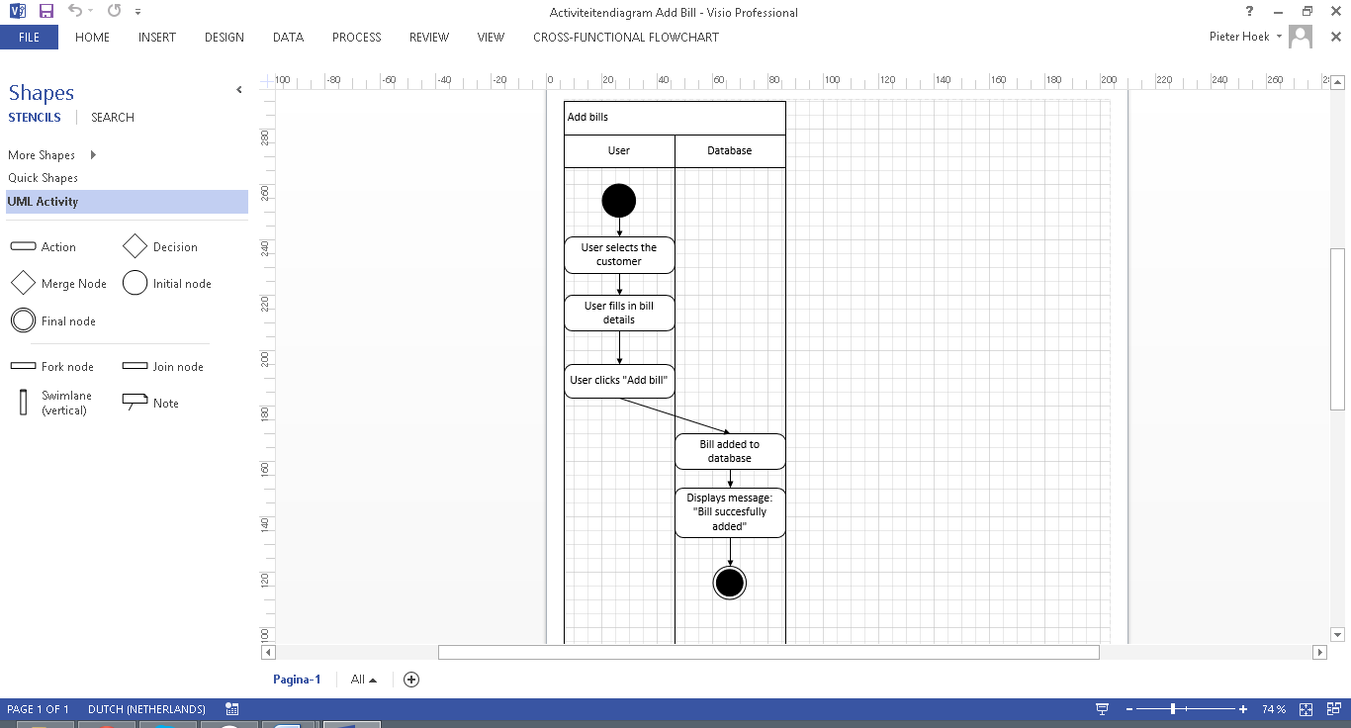

### Archive Bills

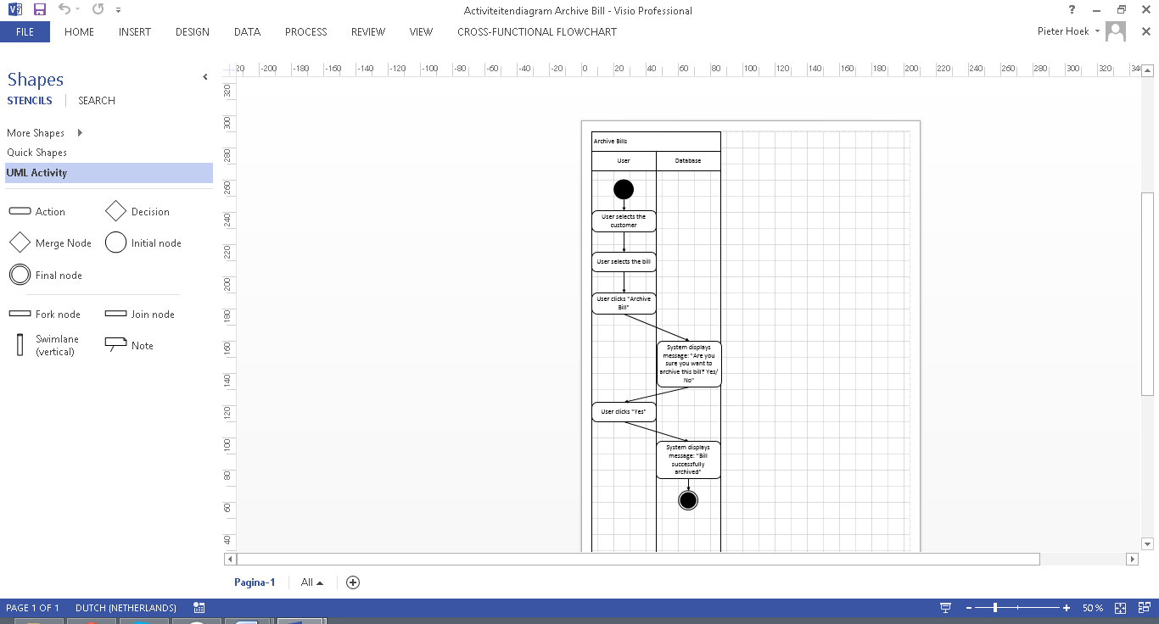

### Edit Bills

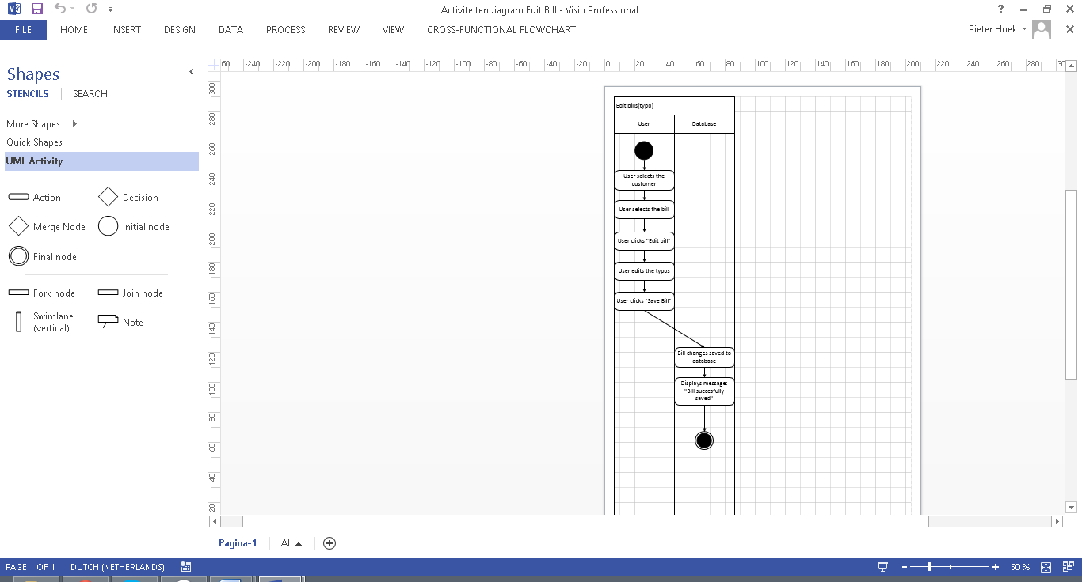

### View Bills

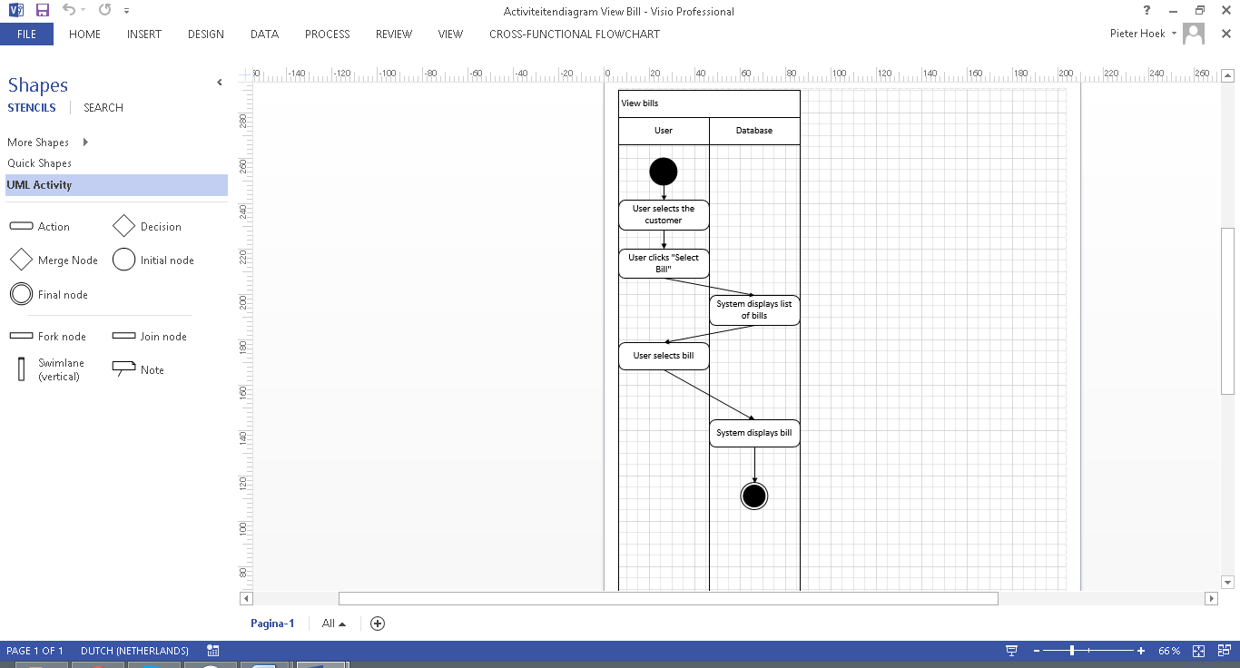

## Customer

### Add Customer

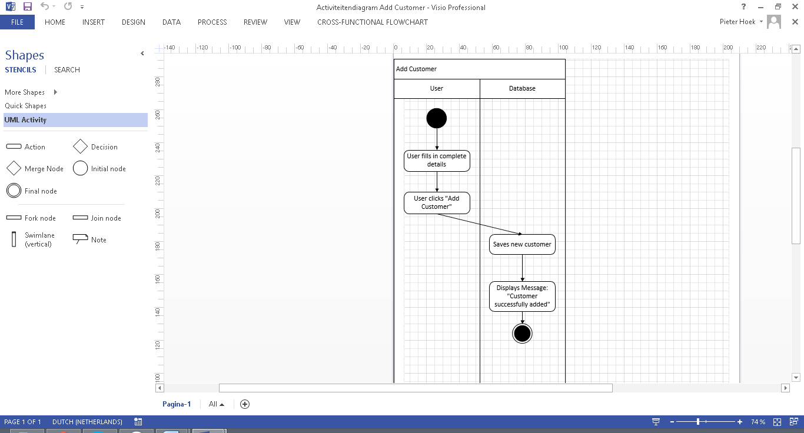

### Archive Customer

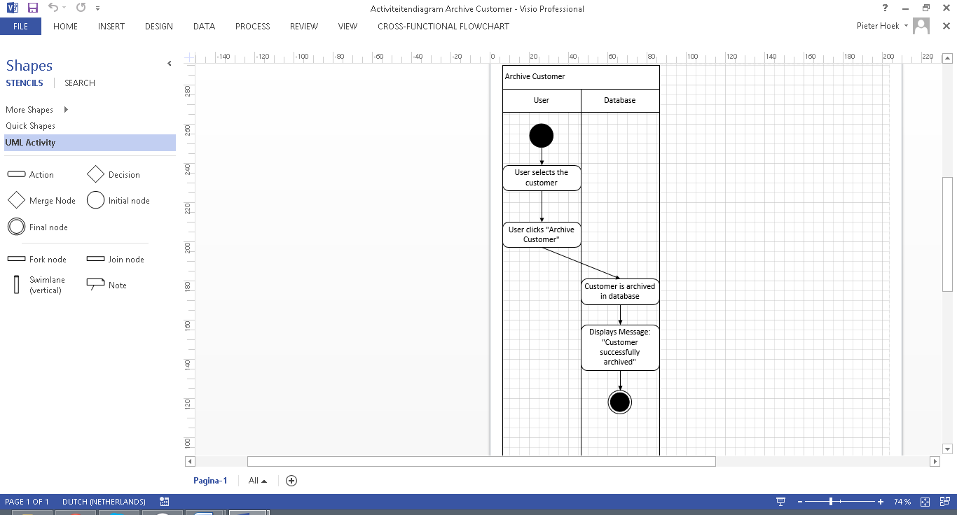

### Edit Customer

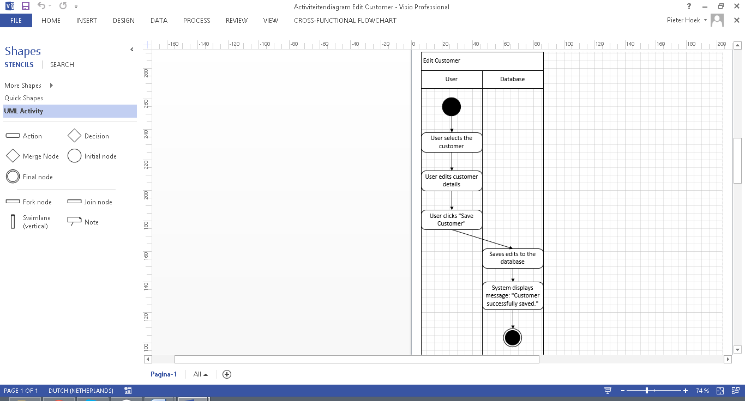

### View Customer

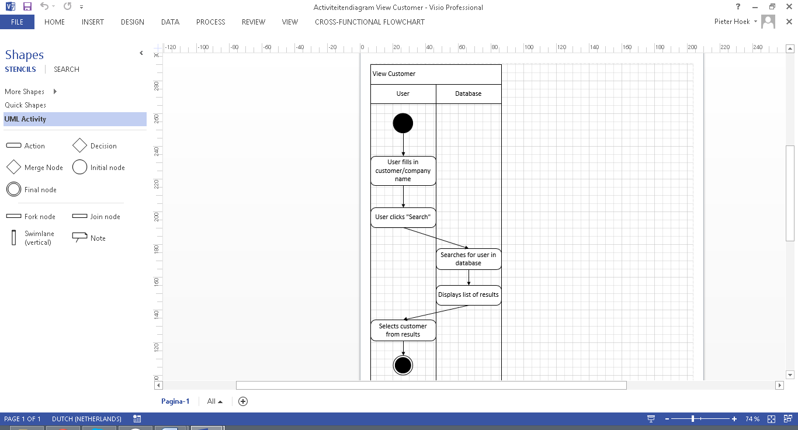

# Versions

|  |  |  |  |
| --- | --- | --- | --- |
| Version | Name | Date | Description |
| 0.1 | Pieter Hoek | 22-09-2014 | * Created document * Created table of contents * Added all the headers * Filled in the rest of the document |
| 1.0 | Marco Havermans | 22-09-2014 | * Completed document |